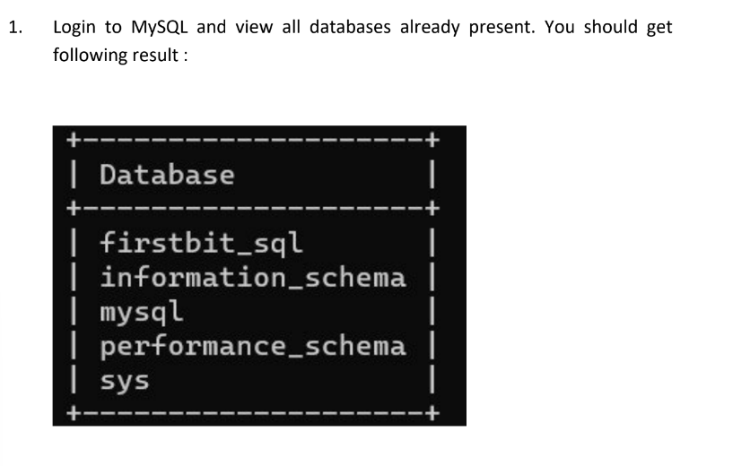

show databases;

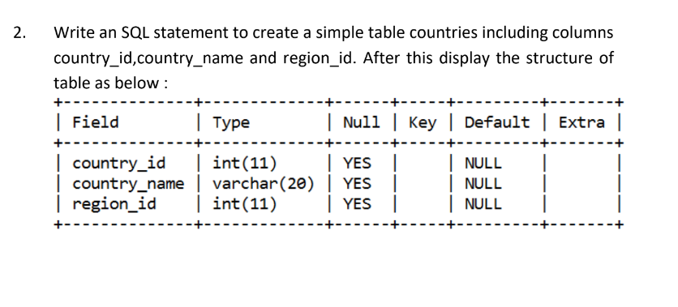

create table countries(
-> country_id int(11),
-> country_name varchar(20),
-> region_id int(11));


create table jobs(
-> job_id int primary key,
-> job_title varchar(20) not null,
-> min_salary int,
-> max_salary int check(max_salary<25000));



create table job_histry(
-> employee_id int,
-> start_date date,
-> end_date date,
-> job_id int,
-> department_id int);


alter table countries
-> add primary key(country_id);

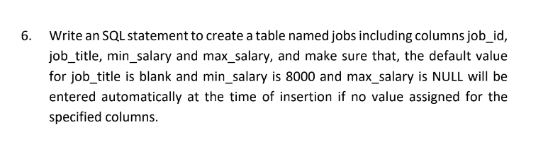

create table jobs2(
-> job_id int,
-> job_title varchar(20) default '___',
-> min_salary int default 8000,
-> max_salary int default null);

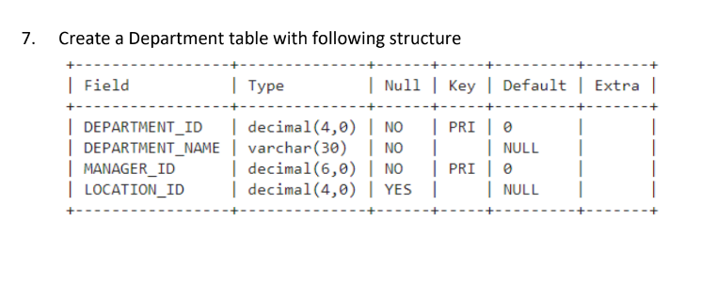
create table Dep(
-> dep_id decimal default 0,
-> dep_name varchar(30) not null,
-> dep_name varchar(30) not null,^C
mysql> create table Dep(
-> dep_id decimal(4,0) default 0,
-> dep_name varchar(30) not null,
-> manager_id decimal(6,0) default 0,
-> location decimal(4,0),
-> primary key(dep_id,manager_id));
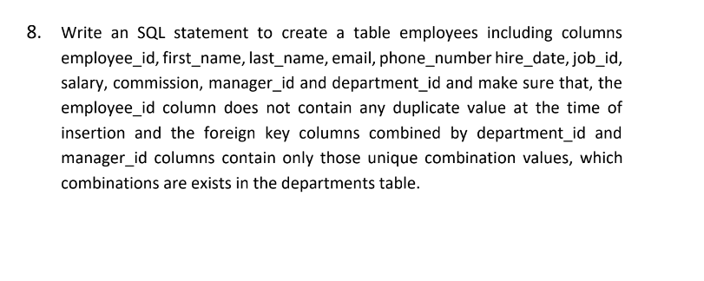
CREATE TABLE emps2(
-> emp_id INT PRIMARY KEY,
-> first_name VARCHAR(20),
-> last_name VARCHAR(20),
-> email VARCHAR(20),
-> phone_number INT,
-> hire_date DATE,
-> job_id INT,
-> salary INT,
-> commission INT,
-> manager_id decimal(4,0),
-> dep_id decimal(4,0),
-> FOREIGN KEY (dep_id, manager_id)
-> REFERENCES Dep(dep_id, manager_id)
-> );

